UX Check Results

# Heuristic: Visibility of system status

# Severity: 4

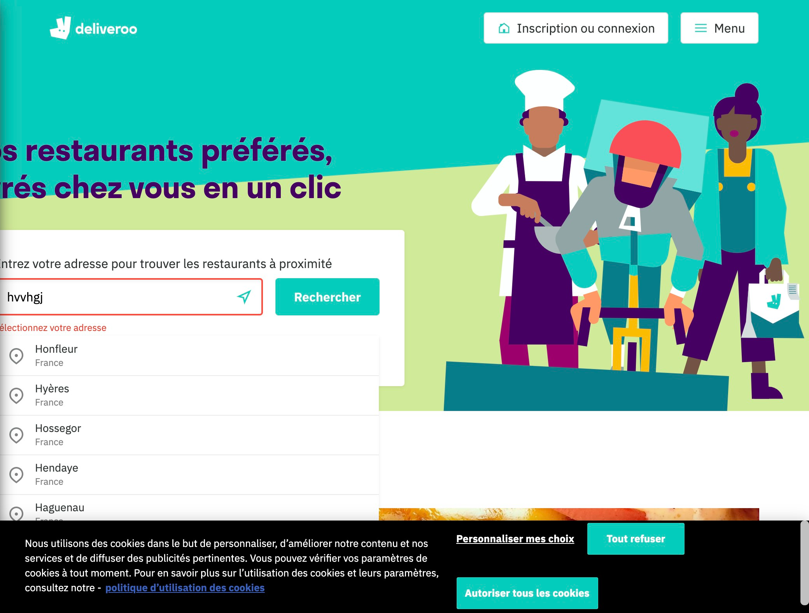

# Notes:

The system shows us an error after entering an unknown location.

# Heuristic: Match between system and the real world

# Severity: 4

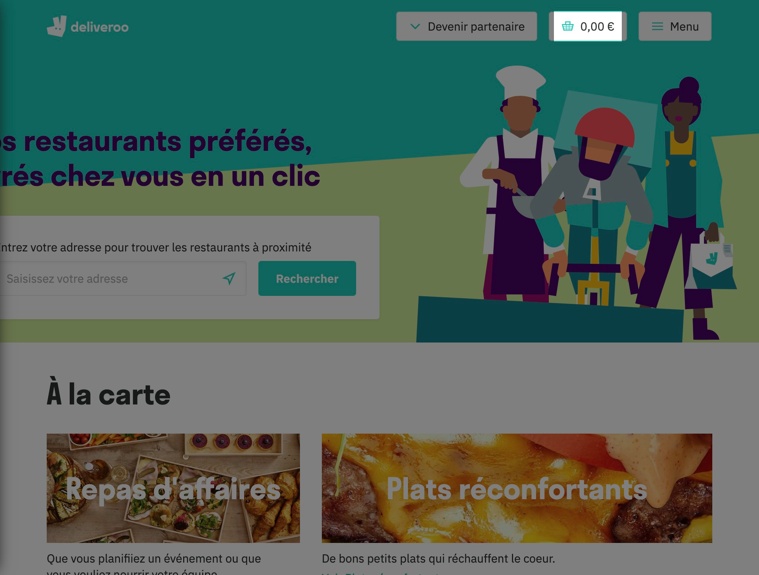

# Notes:

The "basket" icon fulfills the same function than the one in real life we use at the supermarket: to contain purchases before the payment.

# Heuristic: User control and freedom

# Severity: 4

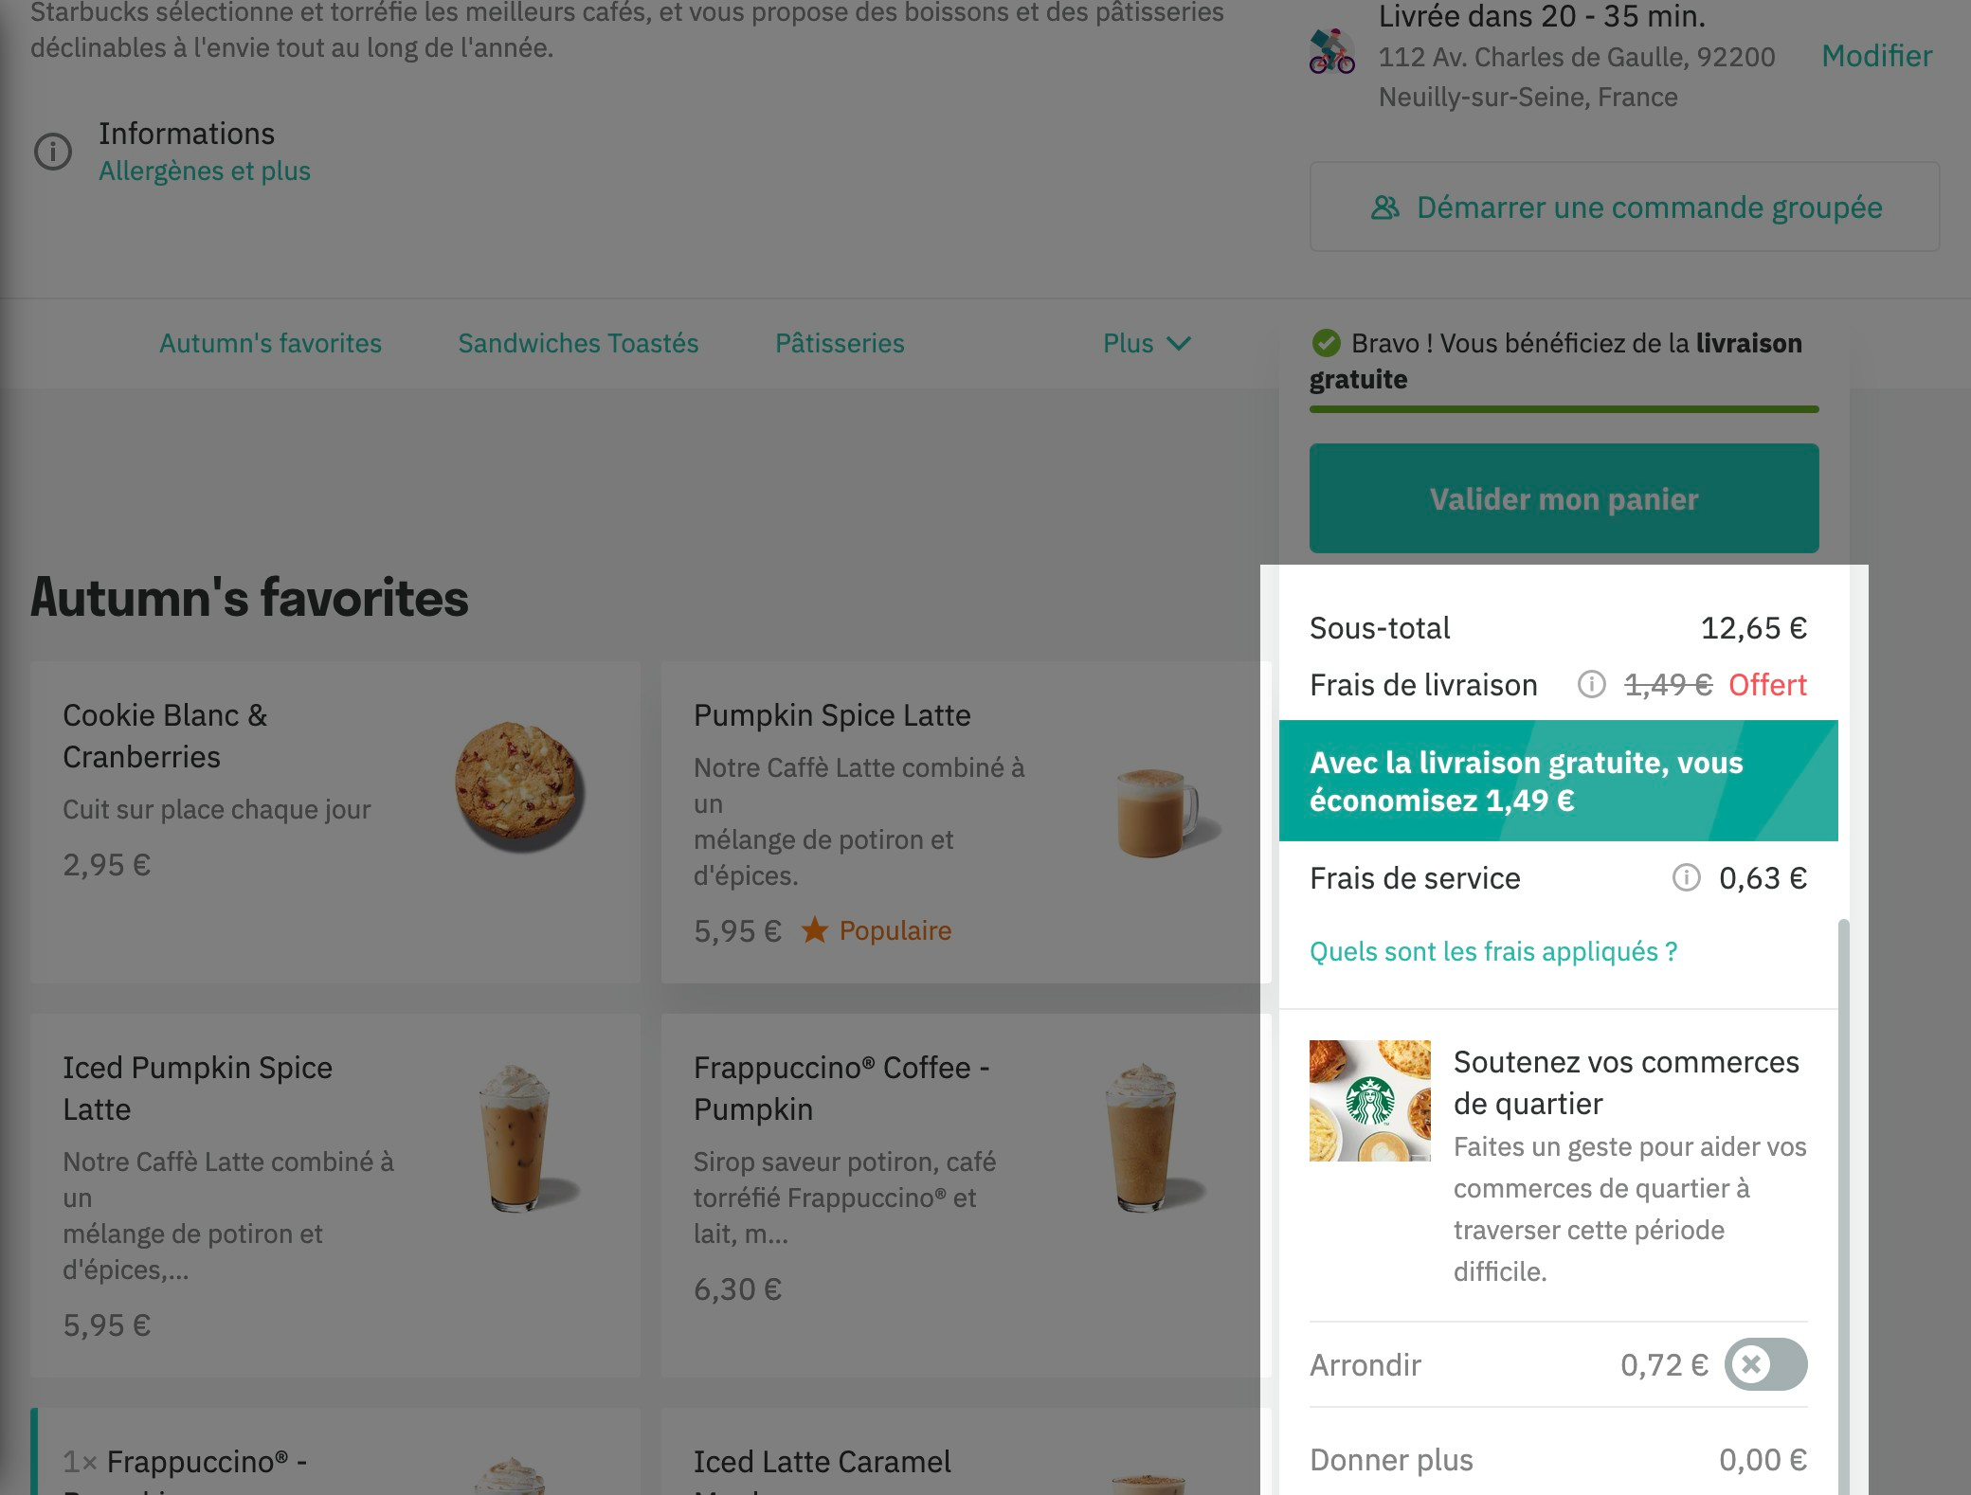

# Notes:

User can add, remove or even delete order.

# Heuristic: Consistency and standards

# Severity: 4

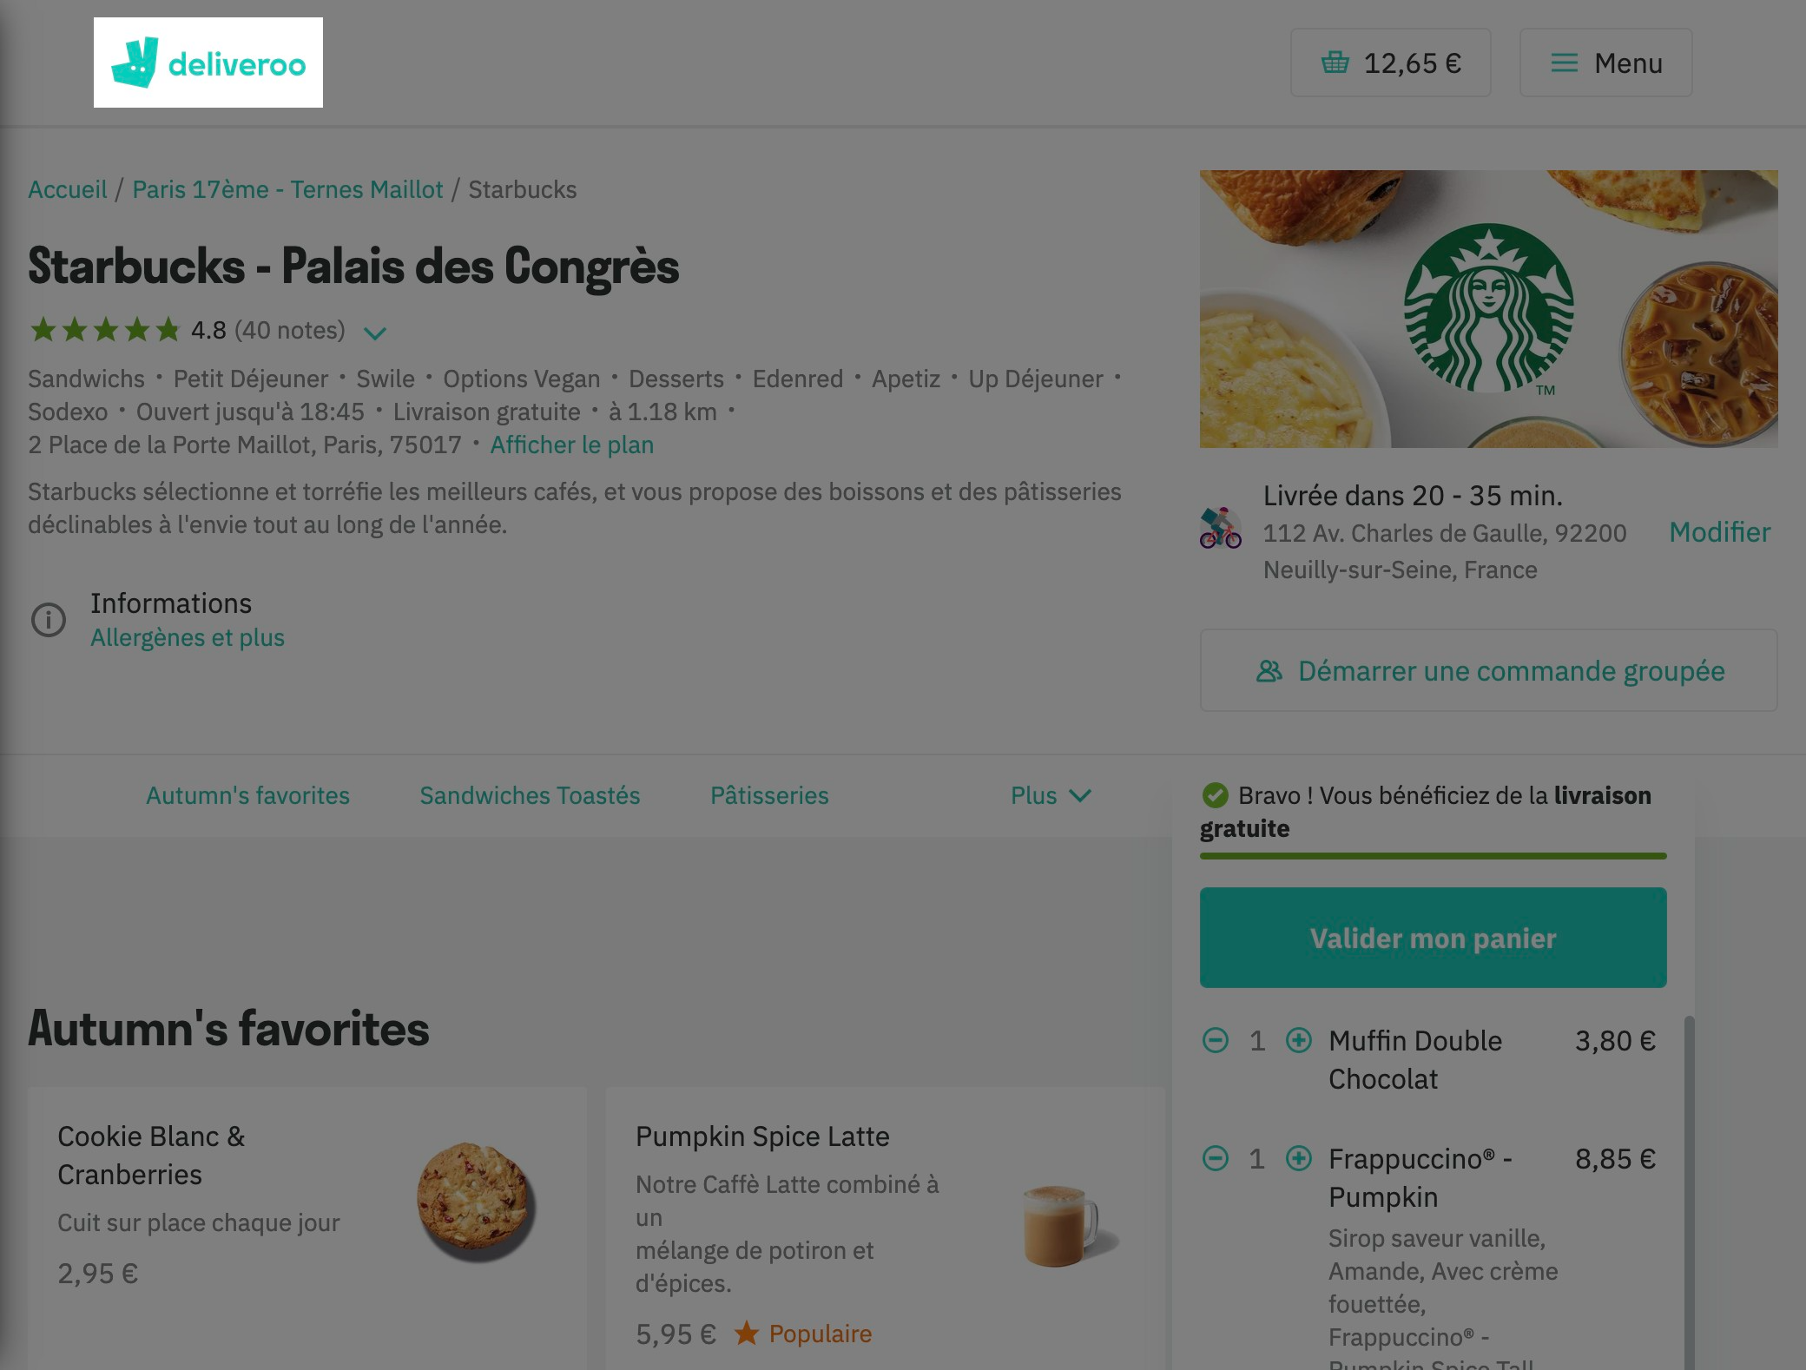

# Notes:

Very standard logo at the top-left corner of the page. It brings us to the home page.

# Heuristic: Error prevention

# Severity: 4

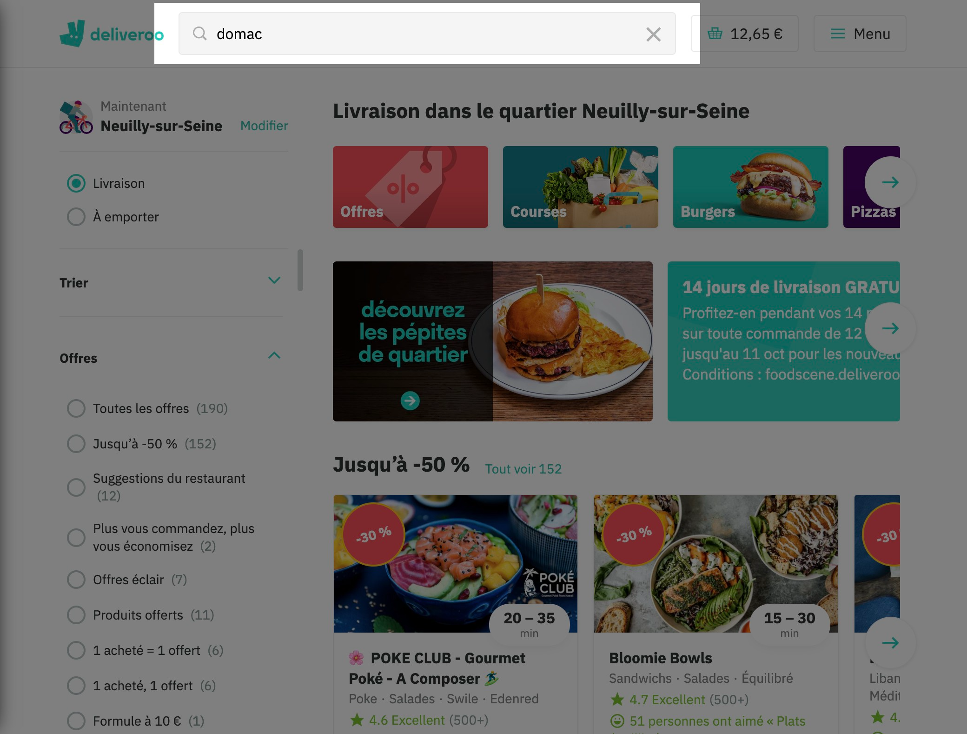

# Notes:

No prevention for the inversion of two syllables for example

# Heuristic: Recognition rather than recall

# Severity: 4

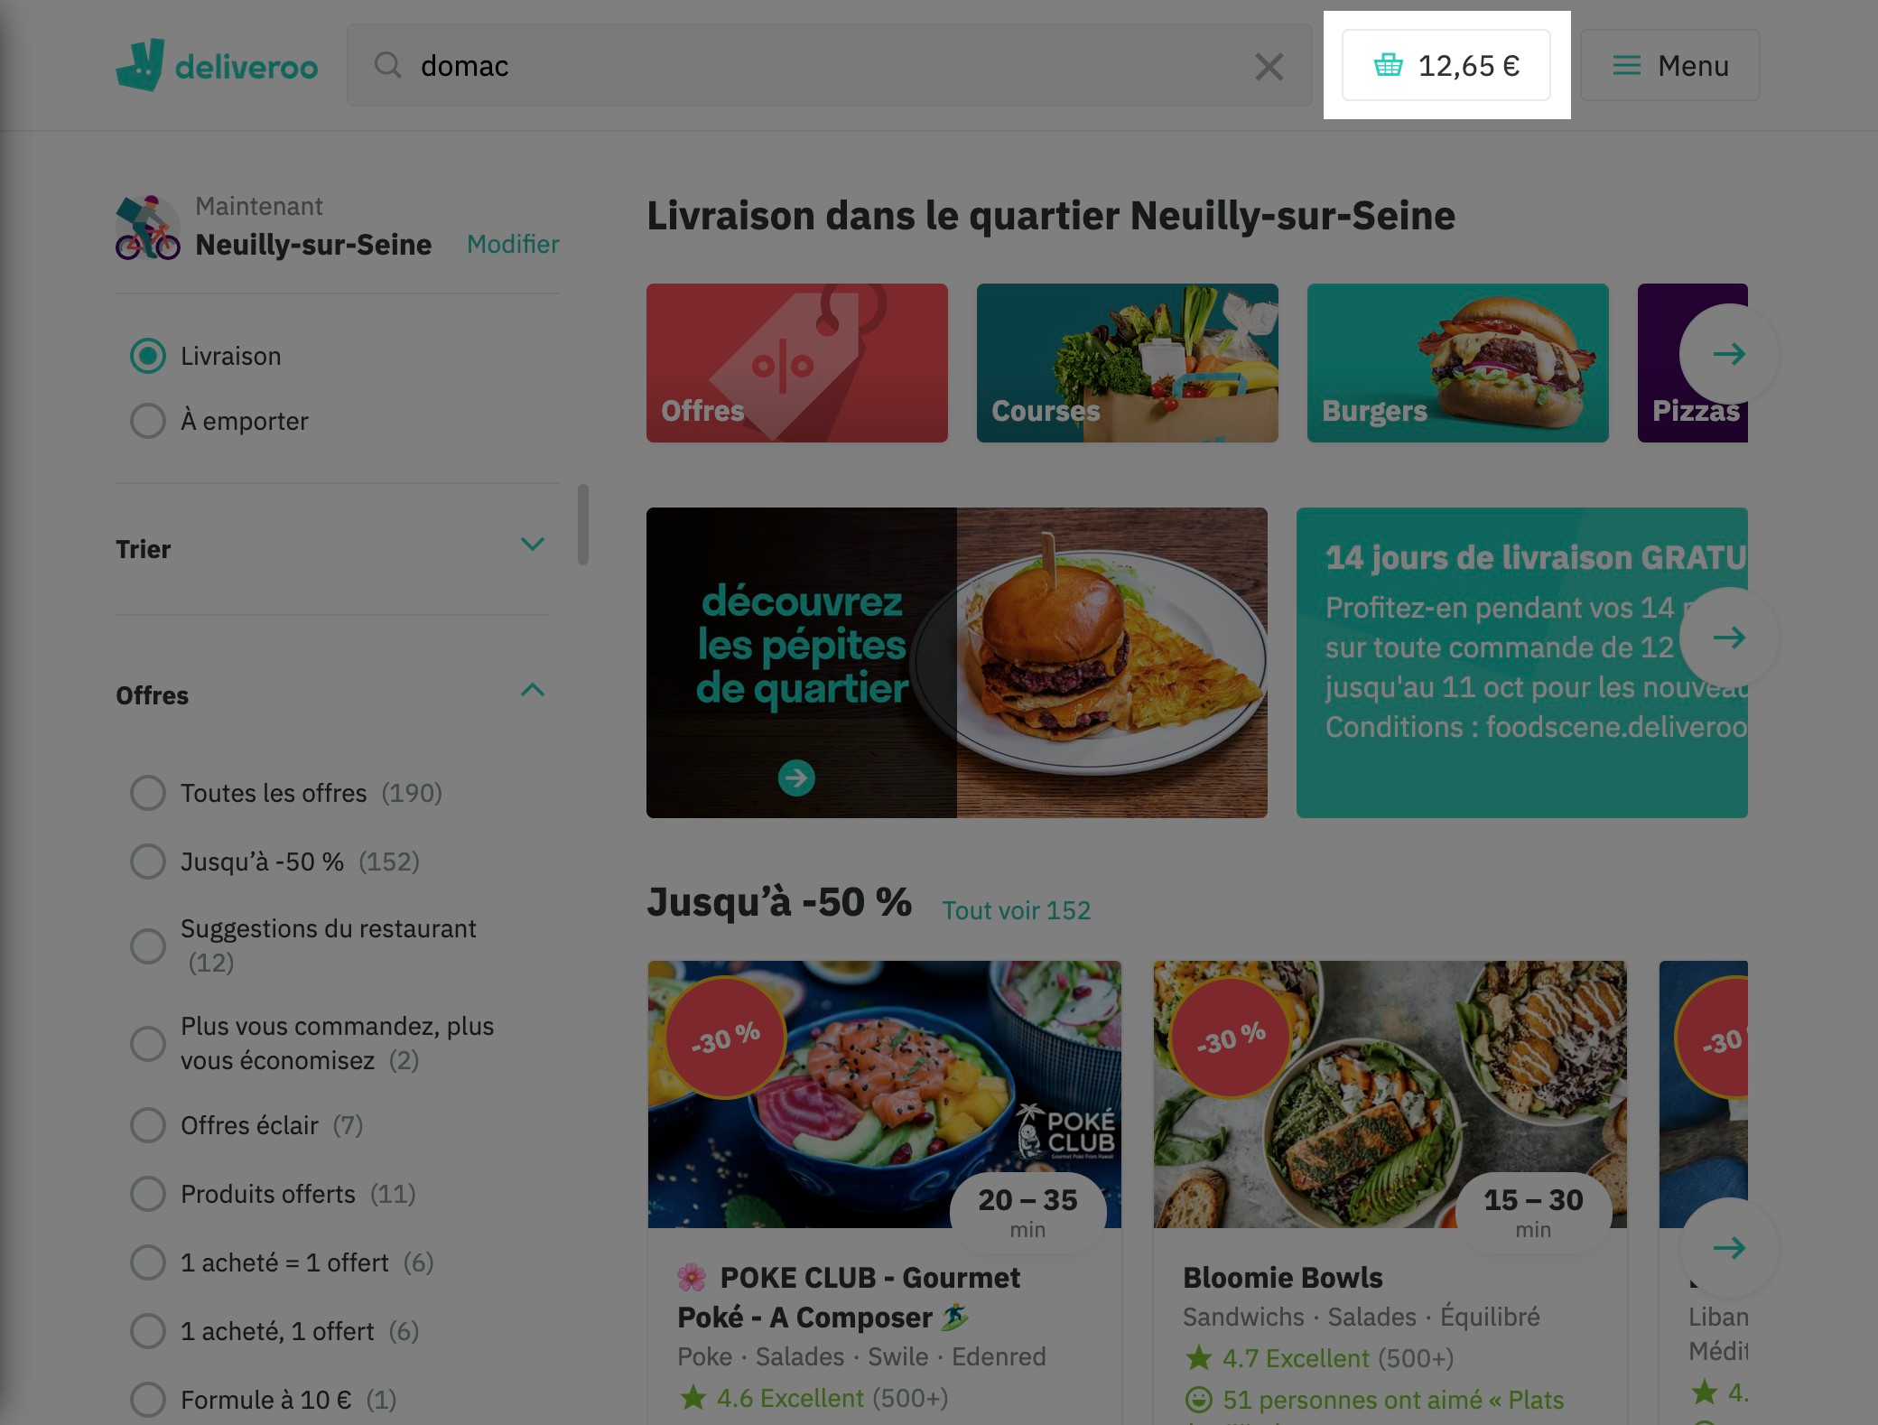

# Notes:

Deliveroo offers a quick access to previously selected commands.

# Heuristic: Flexibility and efficiency of use

# Severity: 4

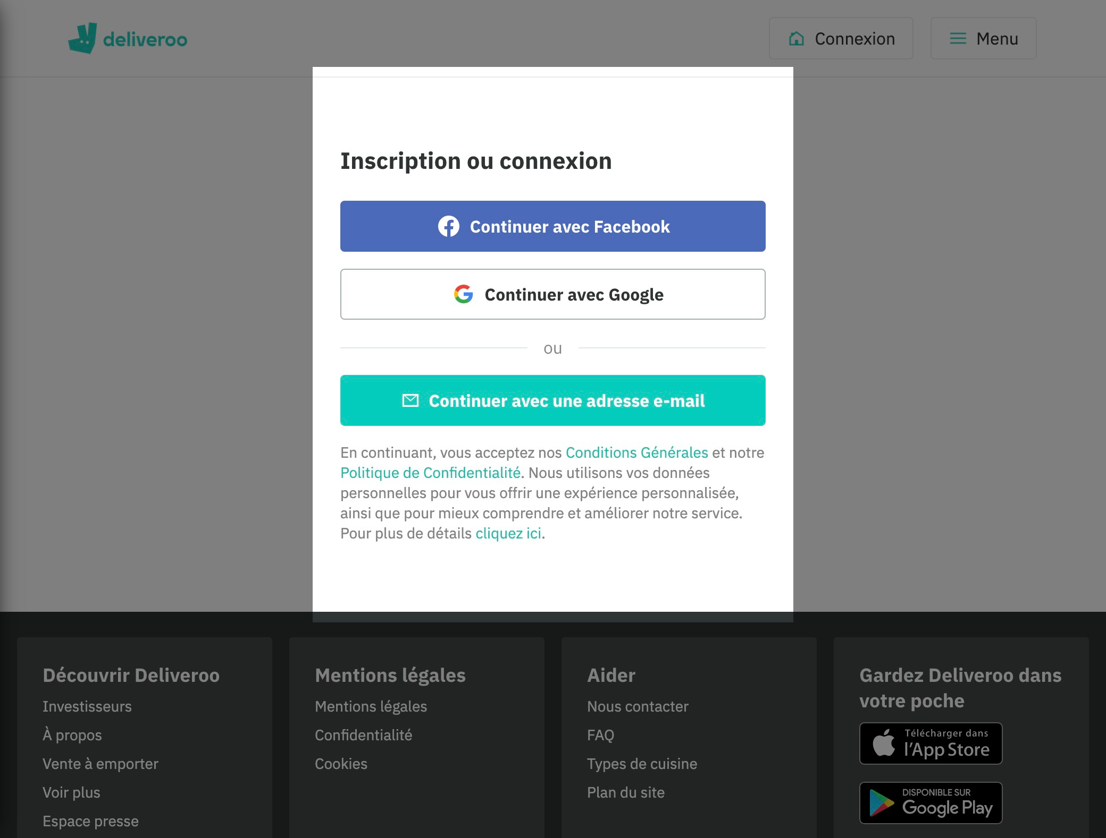

# Notes:

New or novice users can sign up with facebook or google account in order to speed up the registration process

# Heuristic: Aesthetic and minimalist design

# Severity: 4

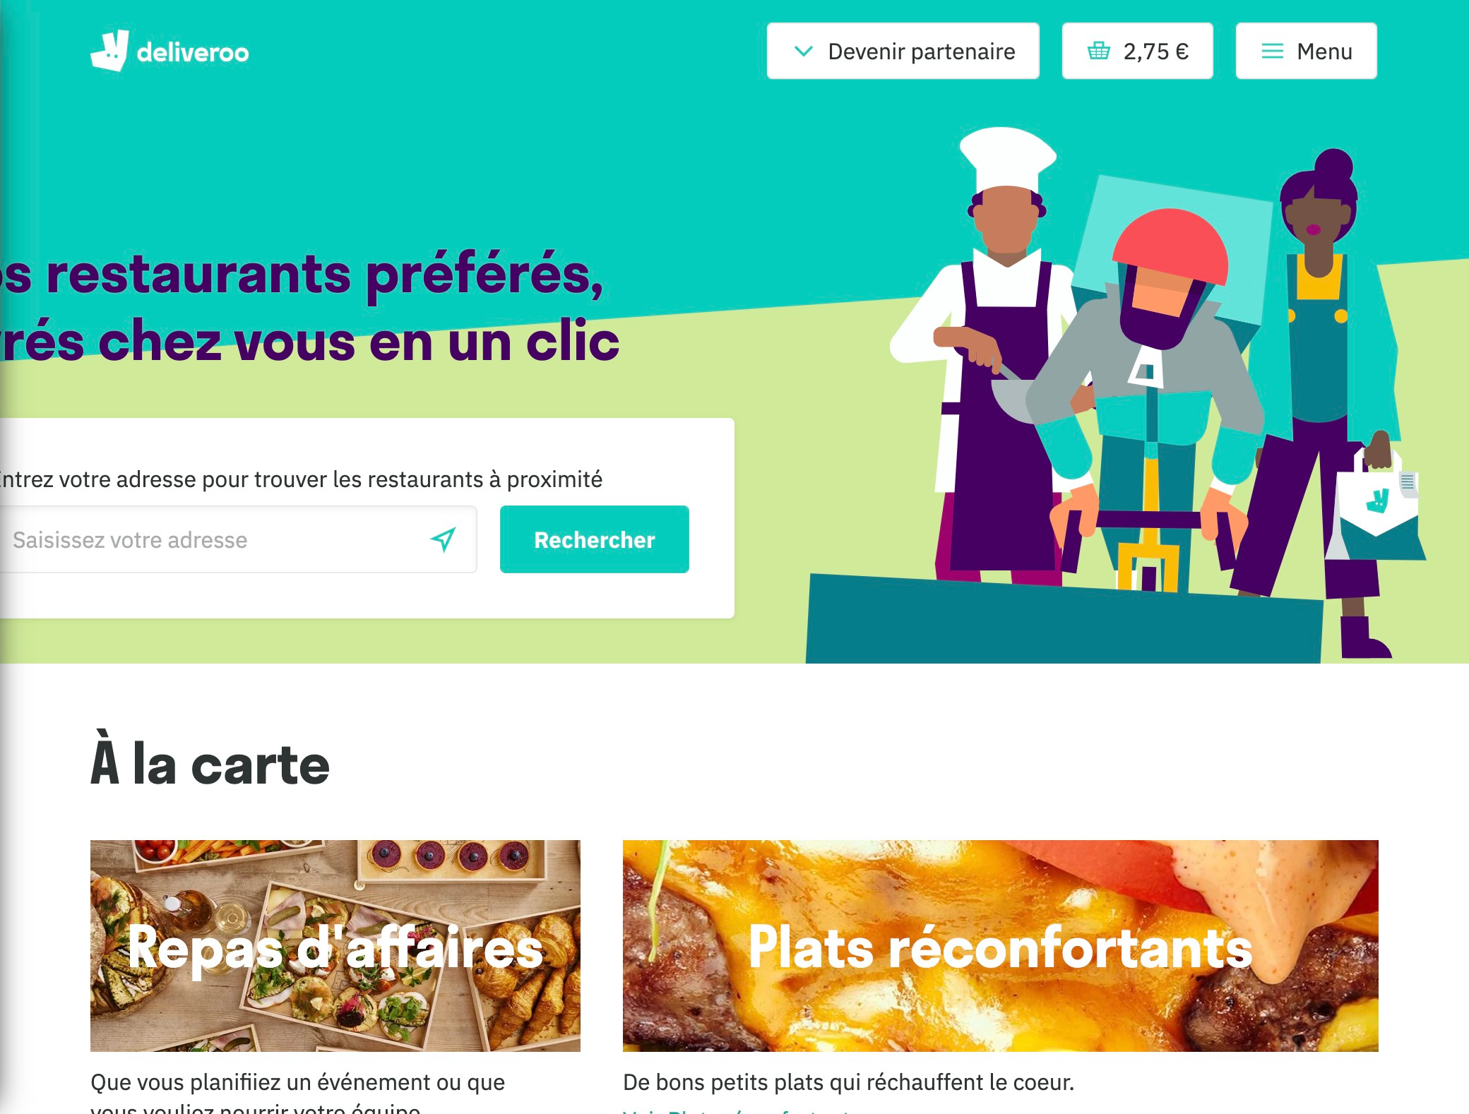

# Notes:

Less is more. Enter your address, choose your restaurant(s), choose your food(s) and then pay.

# Heuristic: Help recognize &amp; recover from errors

# Severity: 4

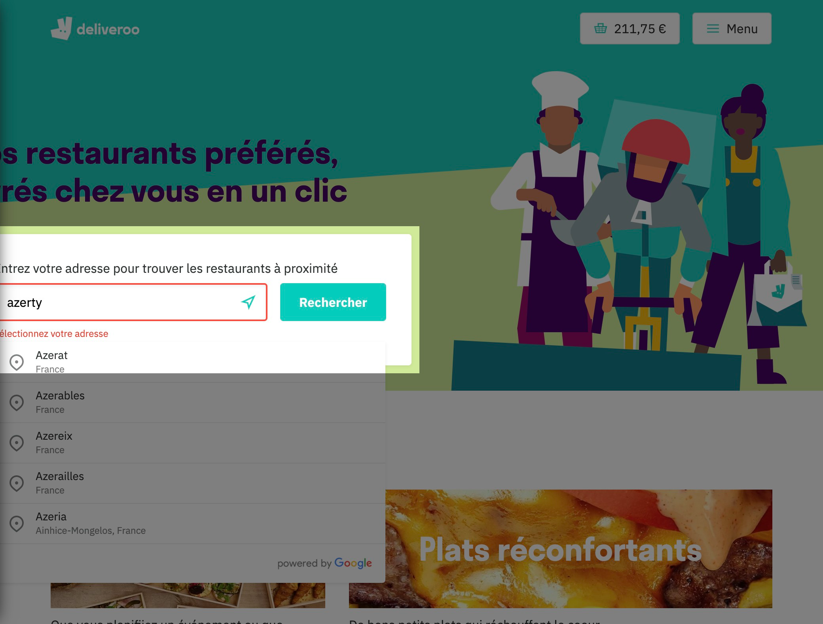

# Notes:

Search bar can't find the address. It shows an alert message in red.

# Heuristic: Help and documentation

# Severity: 4

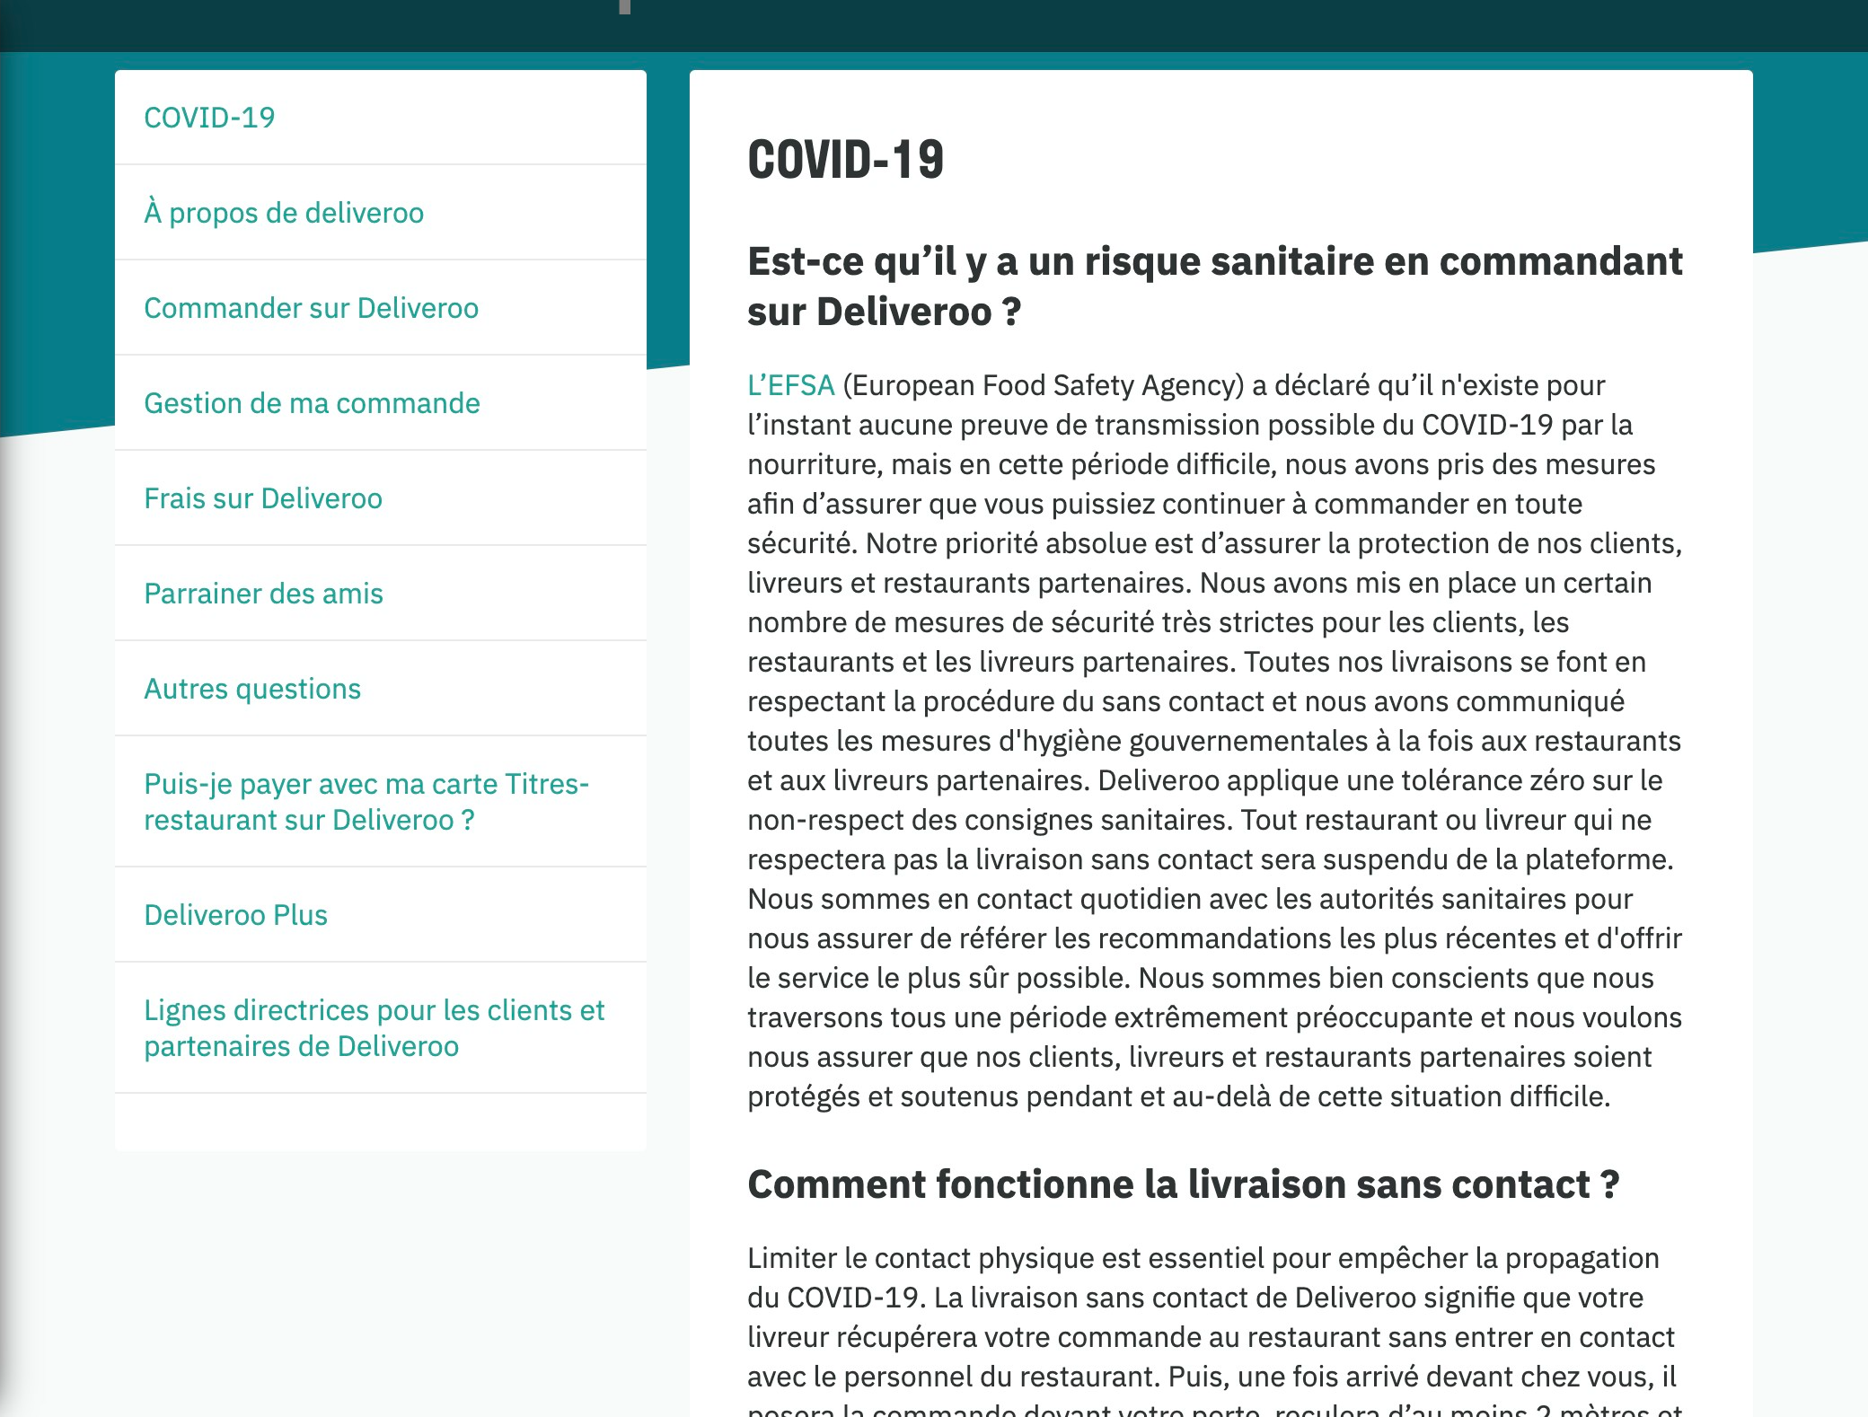

# Notes:

FAQ section has a long list of questions but not a search bar or a contact form to the support if the user cannot find an answer to their question.